**Assignment Day 5**

**Question 1**

1. Add a 10GB disk to the CentOS.

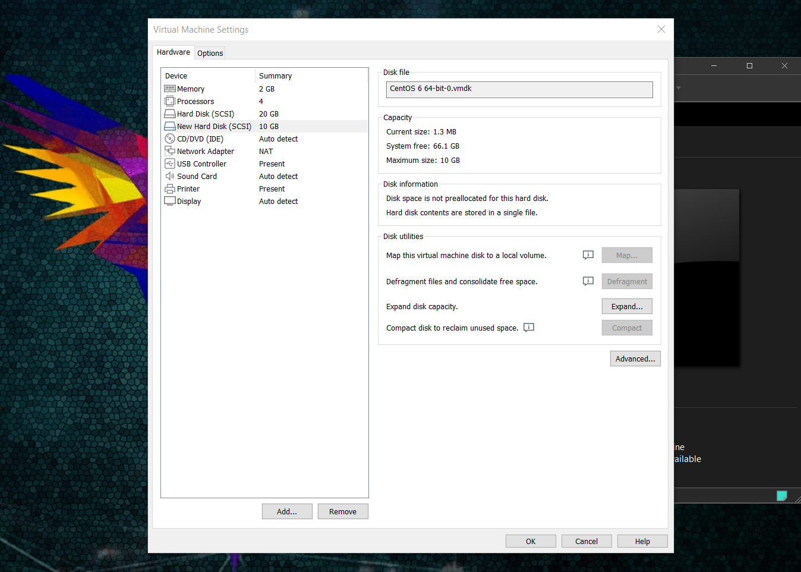

1. Create 2 Partitions 4GB and 6GB of Space respectively.

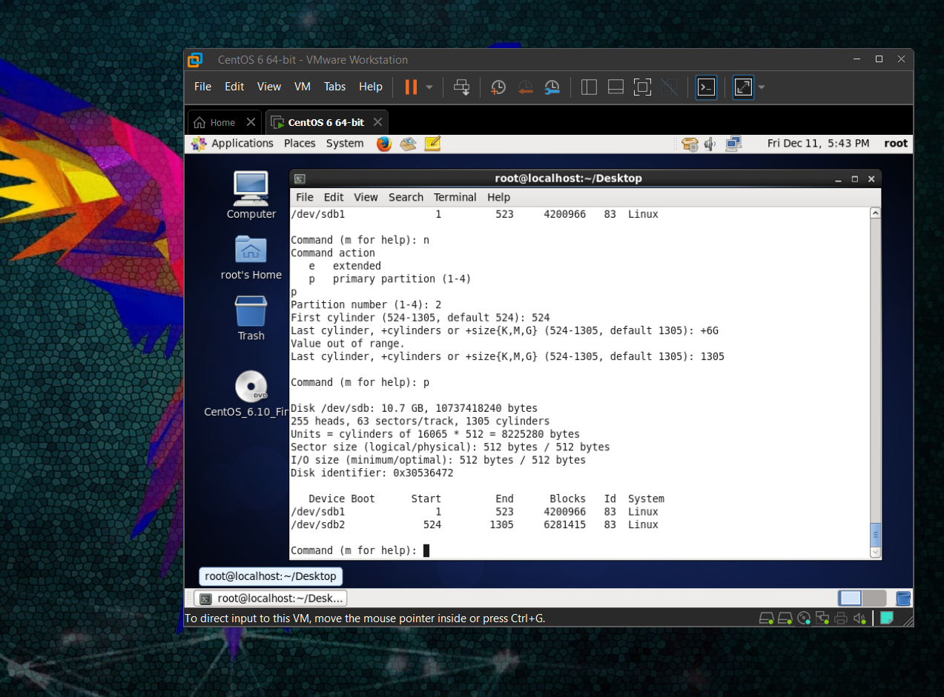

1. Format 4GB with xfs and 6GB with ext4 file system.

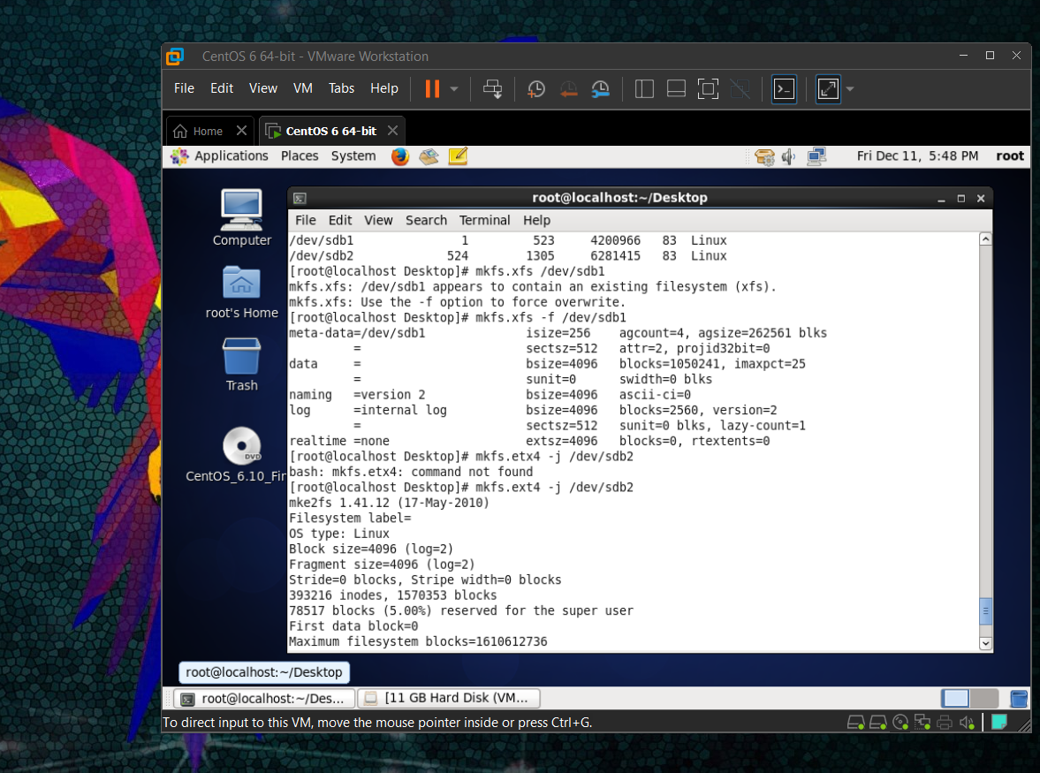

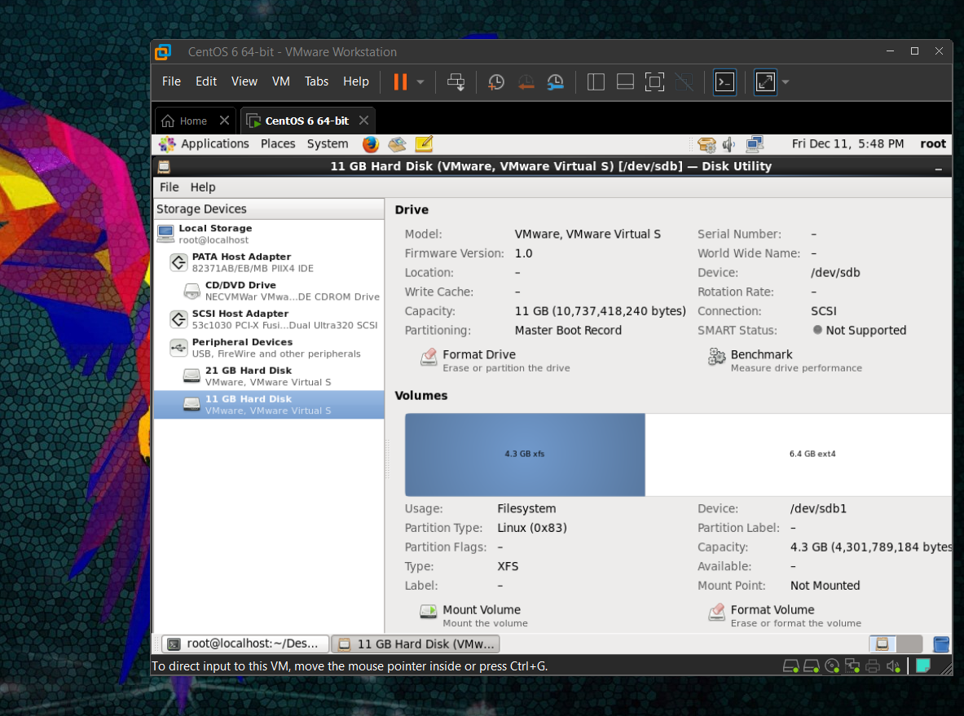

1. Mount 4GB and 6GB in /data and /music directory respectively.

* Temporary mounting

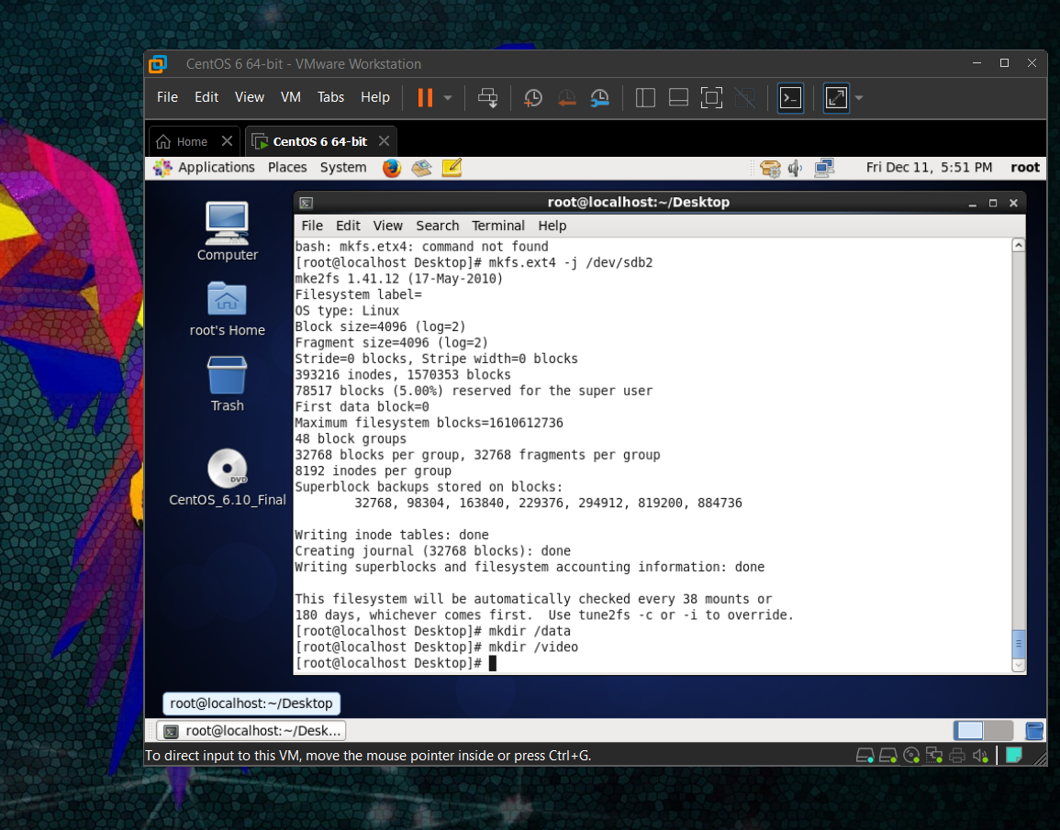

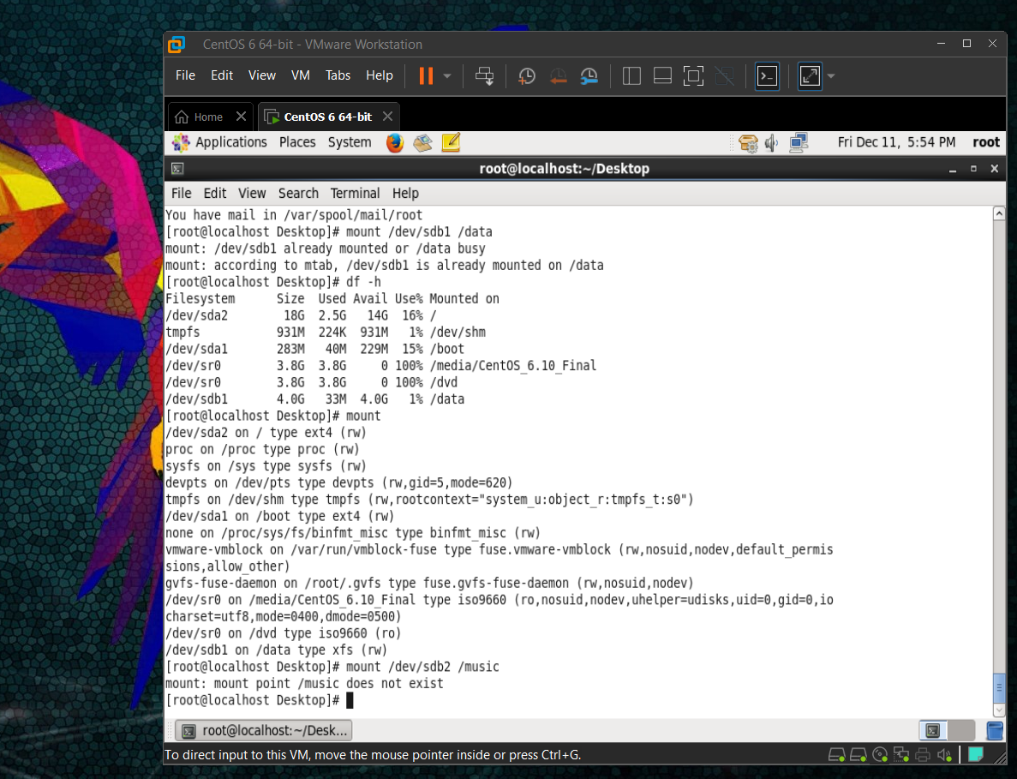

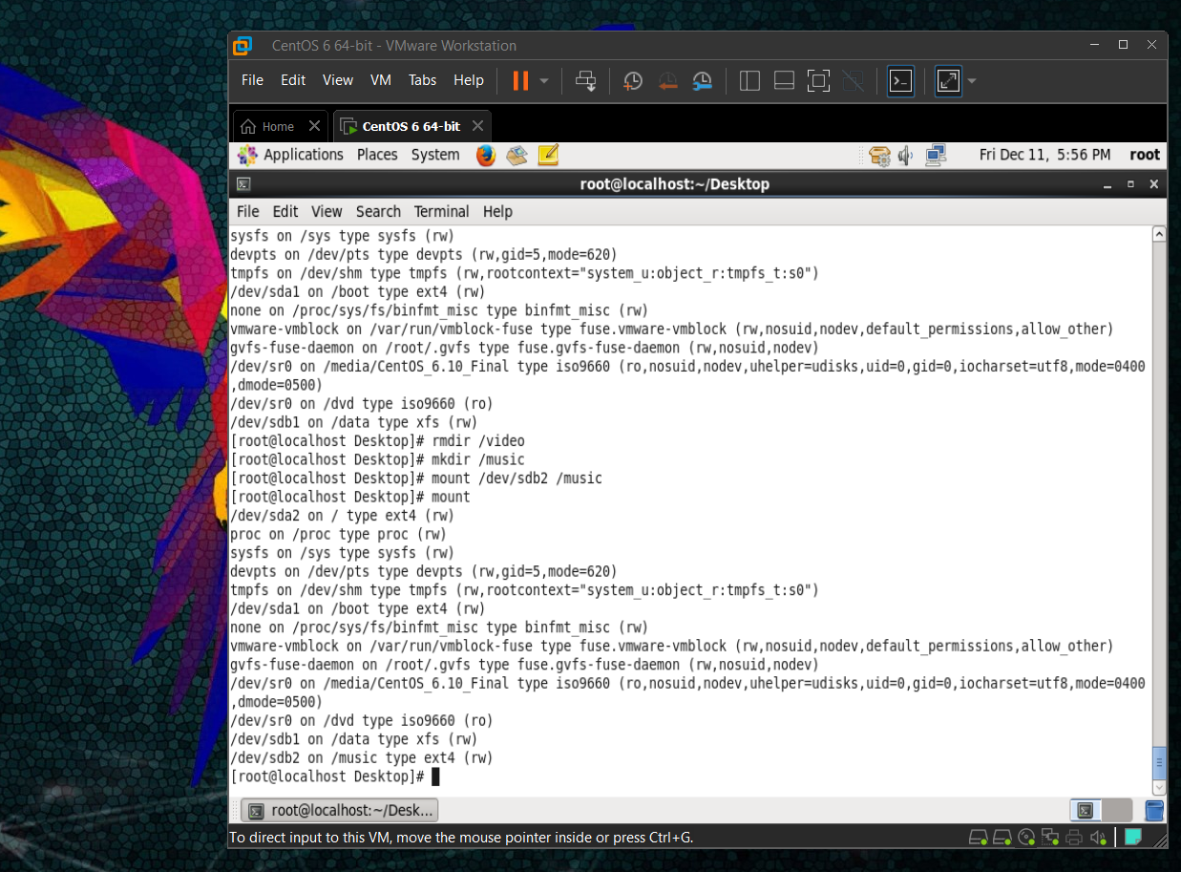

* Permanent mounting

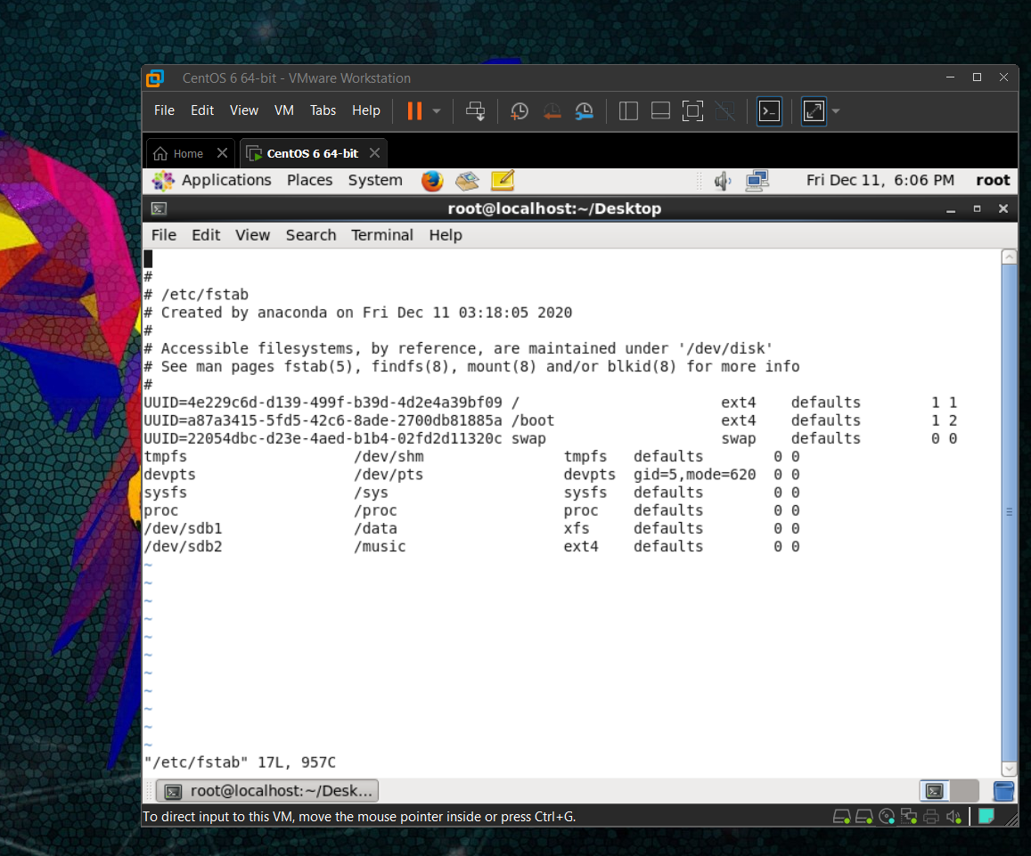

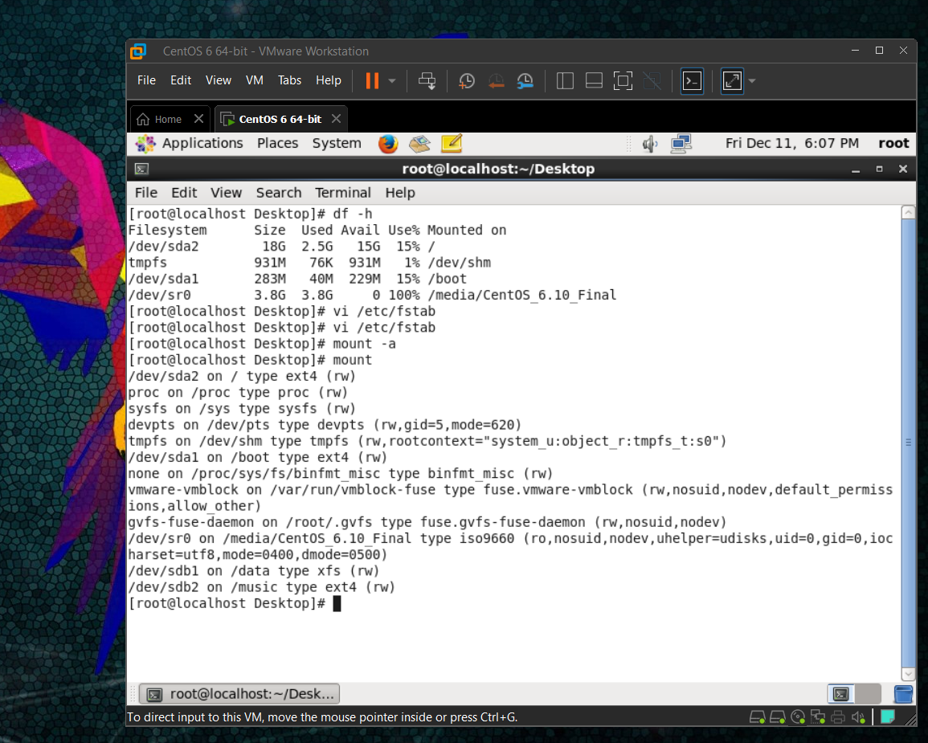

1. Create one file of 1GB in each of the mount point created above.

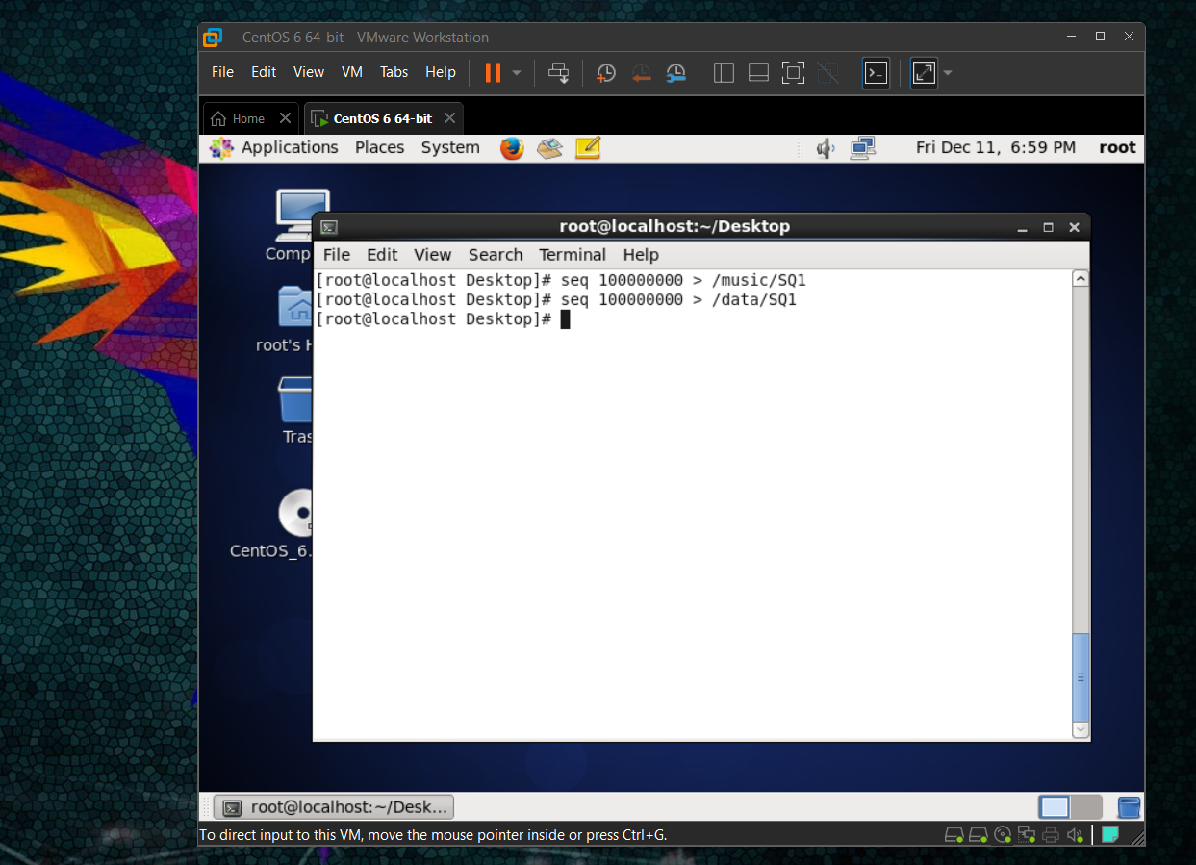

1. Verify the disk Consumption and disk space free in the mounted partitions.

